WEEK 1: DESIGN PATTERNS AND PRINCIPLES

Exercise 1: Implementing the Singleton Pattern
Scenario: You need to ensure that a logging utility class in your application has only one instance throughout the application lifecycle to ensure consistent logging.
//Creation of the Logger calss
class Logger {
private static Logger instance;
private Logger() {
// Initialization of Logger class method
}
public static Logger getInstance() {
if (instance == null) {
instance = new Logger();
}
return instance;
}
public void log(String message) {
System.out.println("Log: " + message);
}
}
class SingletonTest {
public static void main(String[] args) {
Logger logger1 = Logger.getInstance();
Logger logger2 = Logger.getInstance();
logger1.log("This is the first log message.");
logger2.log("This is the second log message.")
if (logger1 == logger2) {
System.out.println("Both logger1 and logger2 are the same instance.");
}
else {
System.out.println("Logger instances are different.");
}
}
}

Output:
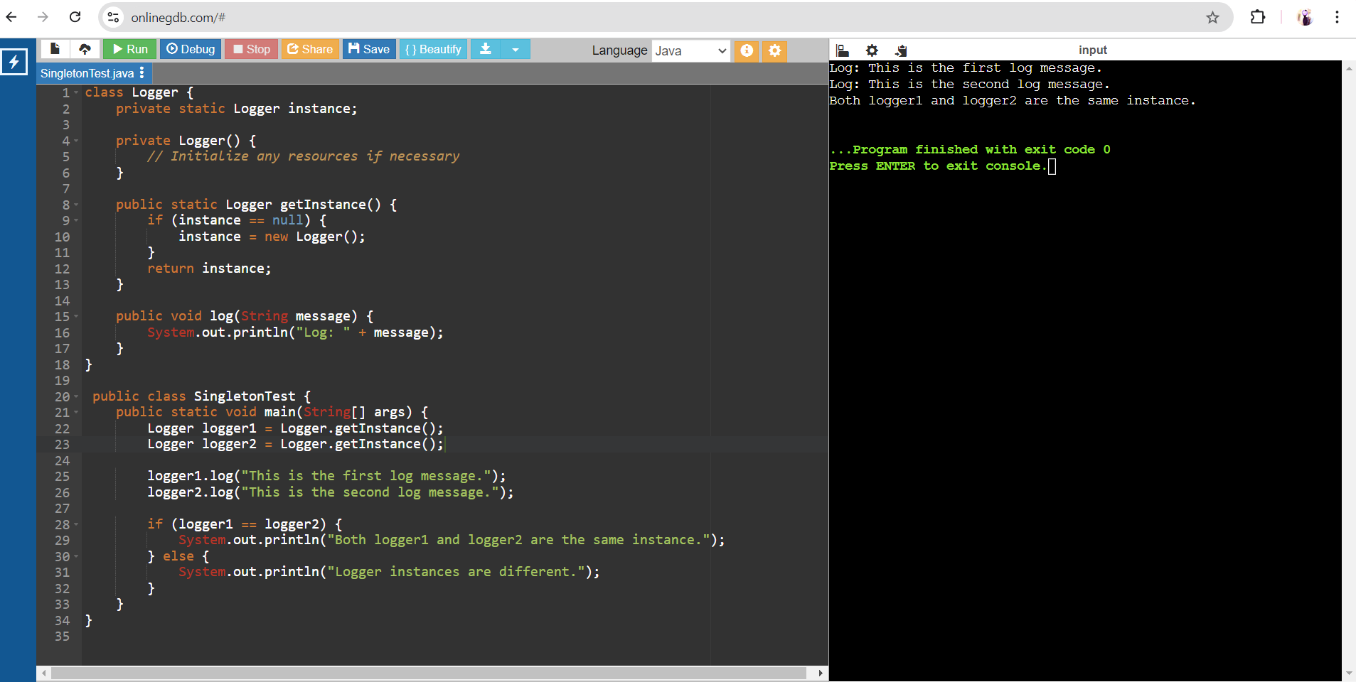

Exercise 2: Implementing the Factory Method Pattern

Scenario: You are developing a document management system that needs to create different types of documents (e.g., Word, PDF, Excel). Use the Factory Method Pattern to achieve this.
interface Document {
void open();
void close();
}
class WordDocument implements Document {
public void open() {
System.out.println("Opening Word document...");
}
public void close() {
System.out.println("Closing Word document...");
}
}
class PdfDocument implements Document {
public void open() {
System.out.println("Opening PDF document...");
}
public void close() {
System.out.println("Closing PDF document...");
}
}
class ExcelDocument implements Document {
public void open() {
System.out.println("Opening Excel document...");
}
public void close() {
System.out.println("Closing Excel document...");
}
}
abstract class DocumentFactory {
public abstract Document create_doc();
}
class WordDocumentFactory extends DocumentFactory {
public Document create_doc() {
return new WordDocument();
}
}
class PdfDocumentFactory extends DocumentFactory {
public Document create_doc() {
return new PdfDocument();
}
}

class ExcelDocumentFactory extends DocumentFactory {
public Document create_doc() {
return new ExcelDocument();
}
}
public class FactoryMethodPatternExample {
public static void main(String[] args) {
DocumentFactory wordFactory = new WordDocumentFactory();
Document wordDocument = wordFactory.create_doc();
wordDocument.open();
wordDocument.close();
DocumentFactory pdfFactory = new PdfDocumentFactory();
Document pdfDocument = pdfFactory.create_doc();
pdfDocument.open();
pdfDocument.close();
DocumentFactory excelFactory = new ExcelDocumentFactory();
Document excelDocument = excelFactory.create_doc();
excelDocument.open();
excelDocument.close();
}
}
Output:
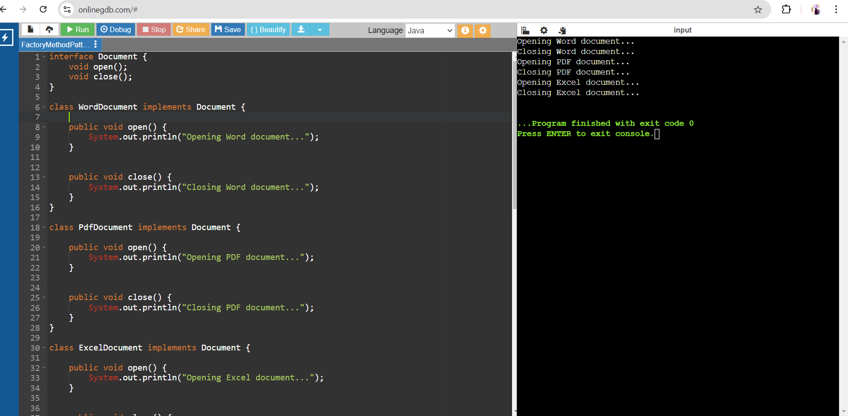

Exercise 3: Implementing the Builder Pattern

Scenario: You are developing a system to create complex objects such as a Computer with multiple optional parts. Use the Builder Pattern to manage the construction process.
public class BuilderPatternExample {
static class Computer {
private String CPU;
private String RAM;
private String storage;
private Computer(Builder builder) {
this.CPU = builder.CPU;
this.RAM = builder.RAM;
this.storage = builder.storage;
}
public static class Builder {

private String CPU;
private String RAM;
private String storage;
public Builder setCPU(String CPU) {
this.CPU = CPU;
return this;
}
public Builder setRAM(String RAM) {
this.RAM = RAM;
return this;
}
public Builder setStorage(String storage) {
this.storage = storage;
return this;
}
public Computer build() {
return new Computer(this);
}
}
}
public static void main(String[] args) {
Computer gamingPC = new Computer.Builder()
.setCPU("Intel Core i9")
.setRAM("32GB")
.setStorage("1TB SSD")
.build();
System.out.println("CPU: " + gamingPC.CPU);
System.out.println("RAM: " + gamingPC.RAM);
System.out.println("Storage: " + gamingPC.storage);
}
}
Output:
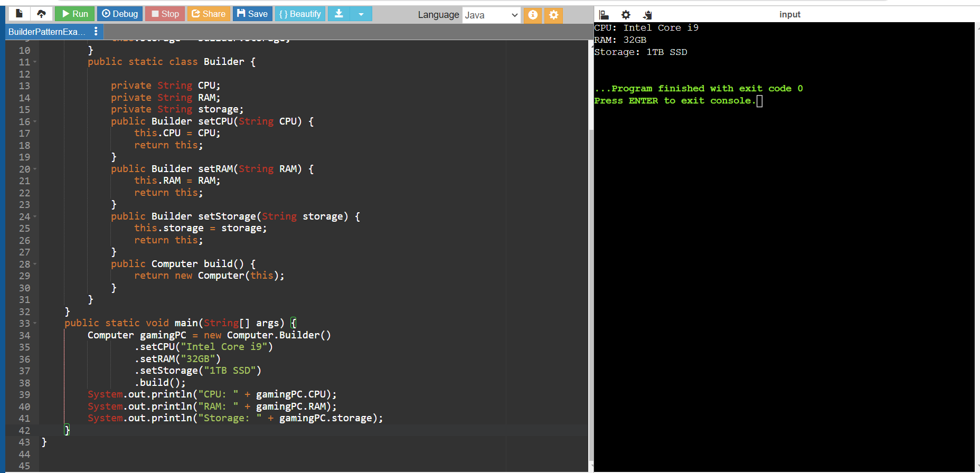

Exercise 4: Implementing the Adapter Pattern

Scenario: You are developing a payment processing system that needs to integrate with multiple third-party payment gateways with different interfaces. Use the Adapter Pattern to achieve this.
interface PaymentProcessor {
void processPayment(double amount);
}

class PayPal {
public void makePayment(double amount) {
System.out.println("Processing payment of Rs." + amount + " through PayPal.");
}
}

class Stripe {
public void pay(double amount) {
System.out.println("Processing payment of Rs." + amount + " through Stripe.");
}
}

class AmazonPay {
public void processTransaction(double amount) {
System.out.println("Processing payment of Rs." + amount + " through Amazon Pay.");
}
}

class PayPalAdapter implements PaymentProcessor {
private PayPal payPal;

public PayPalAdapter(PayPal payPal) {
this.payPal = payPal;
}

public void processPayment(double amount) {
payPal.makePayment(amount);
}
}

class StripeAdapter implements PaymentProcessor {
private Stripe stripe;

public StripeAdapter(Stripe stripe) {
this.stripe = stripe;
}

public void processPayment(double amount) {
stripe.pay(amount);
}
}

class AmazonPayAdapter implements PaymentProcessor {
private AmazonPay amazonPay;

public AmazonPayAdapter(AmazonPay amazonPay) {
this.amazonPay = amazonPay;
}

public void processPayment(double amount) {
amazonPay.processTransaction(amount);
}
}

public class AdapterPatternExample {
public static void main(String[] args) {
PayPal payPal = new PayPal();
Stripe stripe = new Stripe();
AmazonPay amazonPay = new AmazonPay();
PaymentProcessor payPalAdapter = new PayPalAdapter(payPal);
PaymentProcessor stripeAdapter = new StripeAdapter(stripe);
PaymentProcessor amazonPayAdapter = new AmazonPayAdapter(amazonPay);
payPalAdapter.processPayment(100.00);
stripeAdapter.processPayment(200.00);
amazonPayAdapter.processPayment(300.00);
}
}
Output:
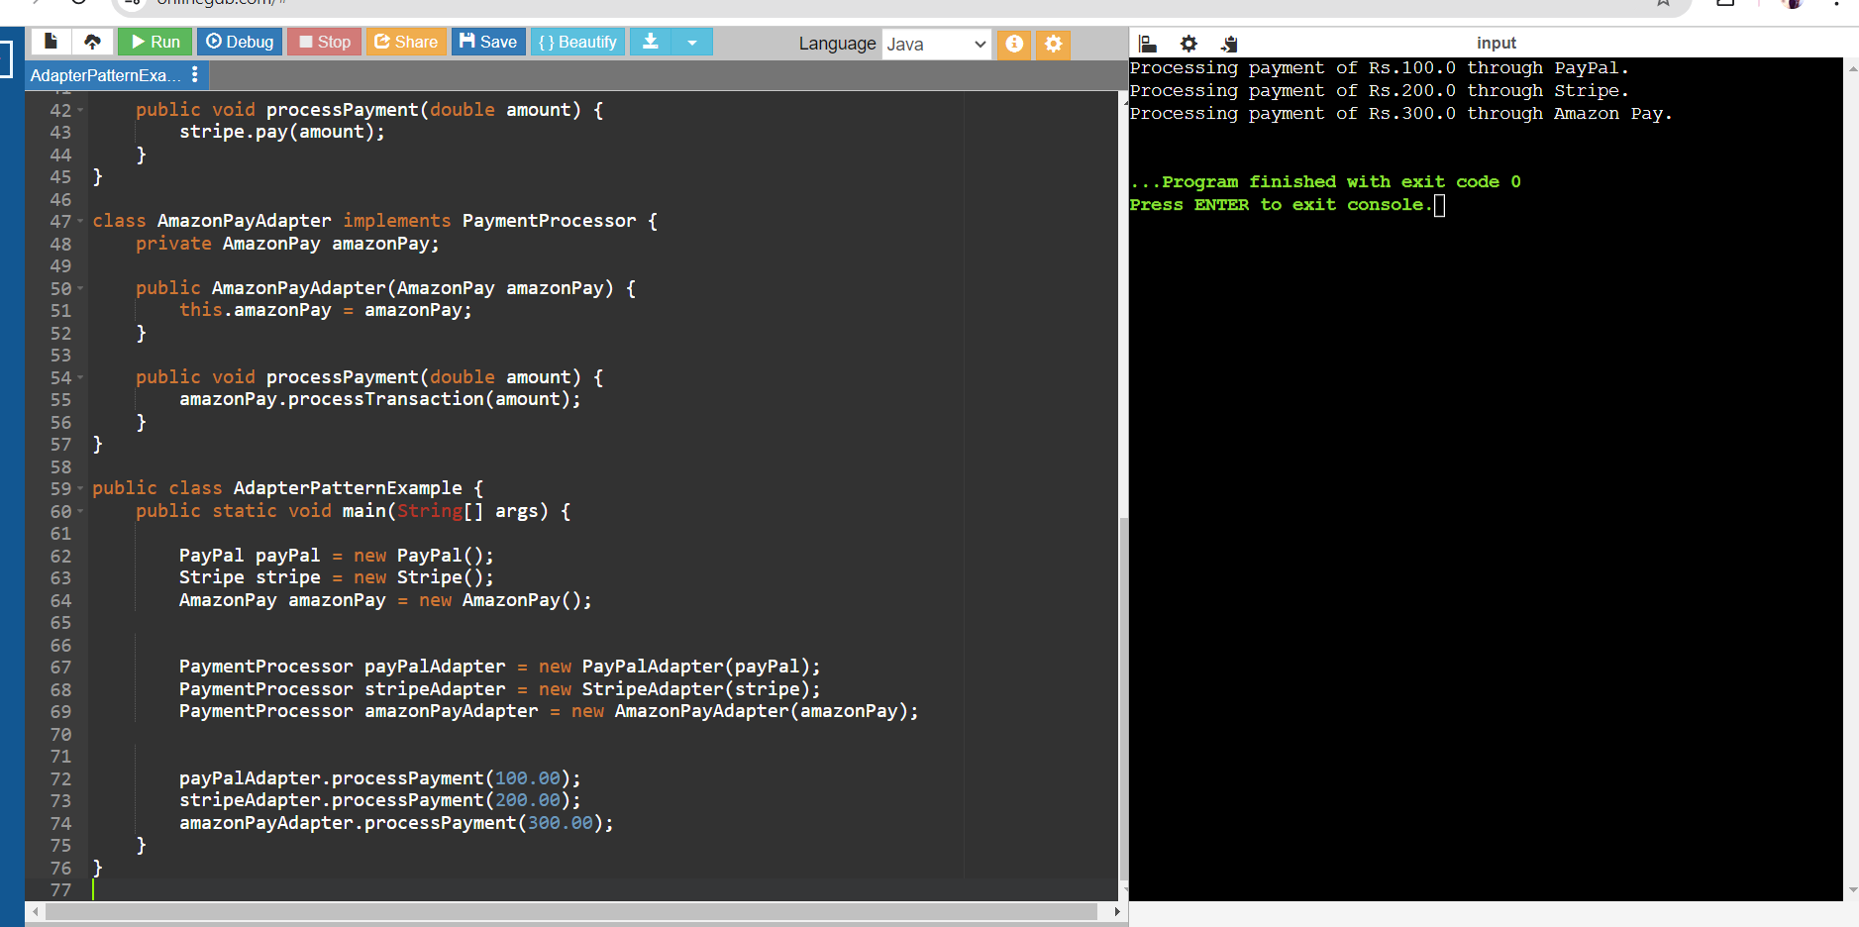

Exercise 5: Implementing the Decorator Pattern

Scenario: You are developing a notification system where notifications can be sent via multiple channels (e.g., Email, SMS). Use the Decorator Pattern to add functionalities dynamically
//Define Notifier Interface
interface Notifier {
void send(String message);
}
class Email implements Notifier {
public void send(String message) {
System.out.println("Sending email notification: " + message);
}
}
abstract class NotifierDecorator implements Notifier {
protected Notifier notifier;
public NotifierDecorator(Notifier notifier) {
this.notifier = notifier;
}
public void send(String message) {
notifier.send(message);
}
}
class SMSNotifierDecorator extends NotifierDecorator {
public SMSNotifierDecorator(Notifier notifier) {
super(notifier);
}
public void send(String message) {
notifier.send(message);
sendSMS(message);
}
private void sendSMS(String message) {
System.out.println("Sending SMS notification: " + message);
}}
class SlackNotifierDecorator extends NotifierDecorator {
public SlackNotifierDecorator(Notifier notifier) {
super(notifier);
}
public void send(String message) {
notifier.send(message);
sendSlack(message);
}
private void sendSlack(String message) {
System.out.println("Sending Slack notification: " + message);
}}
public class DecoratorPatternExample {
public static void main(String[] args) {
Notifier email_notify = new Email ()
Notifier sms_notify = new SMSNotifierDecorator(emailNotifier);
Notifier slack_notify = new SlackNotifierDecorator(smsNotifier);
slack_notify.send("Hello, this is a test notification!"); }}
Output:
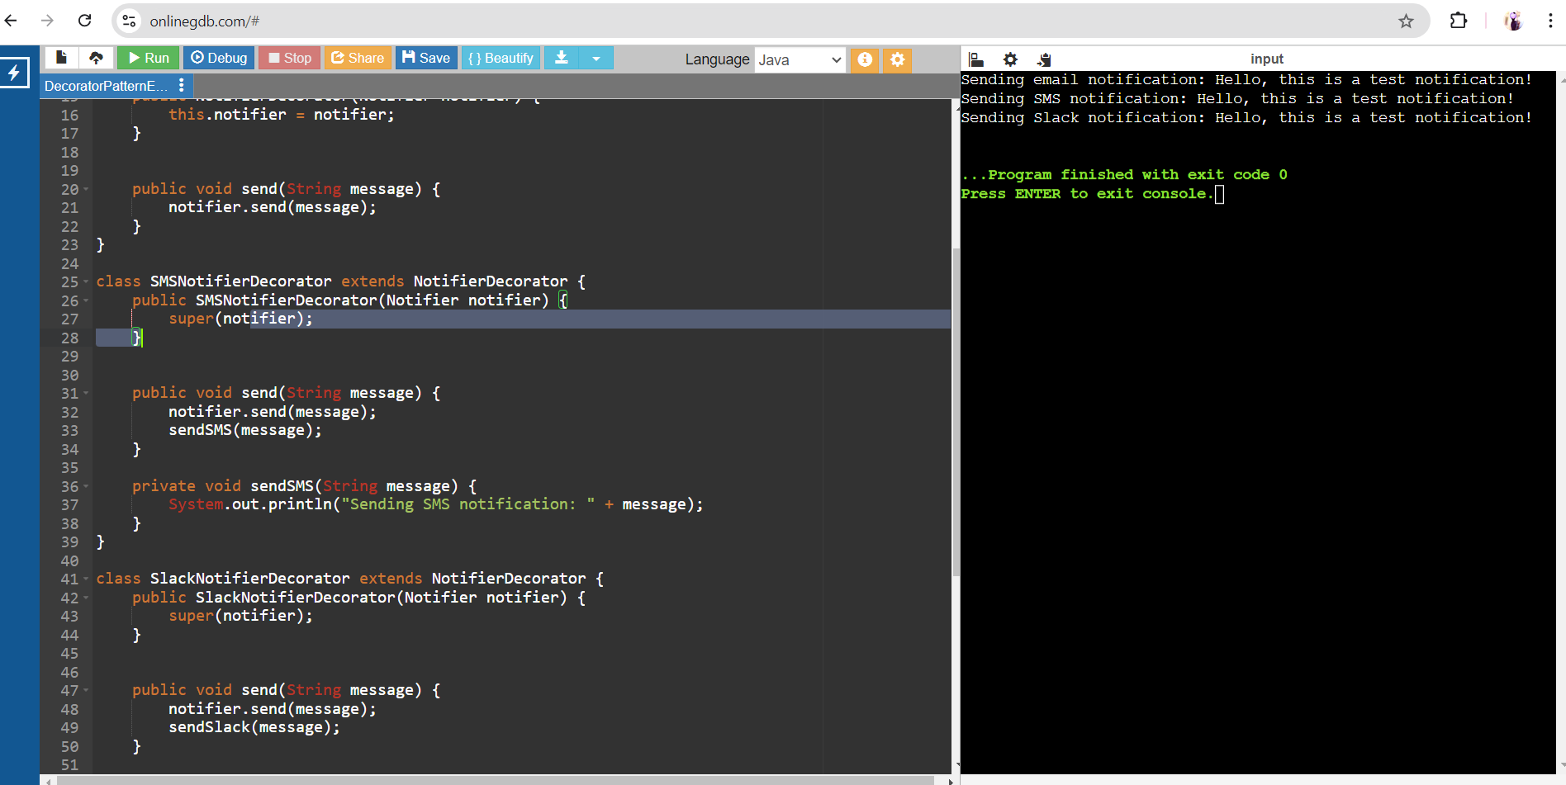

Exercise 6: Implementing the Proxy Pattern

Scenario: You are developing an image viewer application that loads images from a remote server. Use the Proxy Pattern to add lazy initialization and caching
interface Image {
void display();
}
class RealImage implements Image {
private String filename;

public RealImage(String filename) {
this.filename = filename;
loadImageFromDisk();
}
private void loadImageFromDisk() {
System.out.println("Loading image from disk: " + filename);
}
public void display() {
System.out.println("Displaying image: " + filename);
}
}
class ProxyImage implements Image {
private String filename;
private RealImage realImage;
public ProxyImage(String filename) {
this.filename = filename;
}
public void display() {
if (realImage == null) {
realImage = new RealImage(filename);
}
realImage.display();
}
}
public class ProxyPatternExample {
public static void main(String[] args) {
Image image1 = new ProxyImage("image1.jpg");
Image image2 = new ProxyImage("image2.jpg");
image1.display();
System.out.println("");
image1.display();
System.out.println("");
image2.display();
System.out.println("");
image2.display();
}
}
Output:
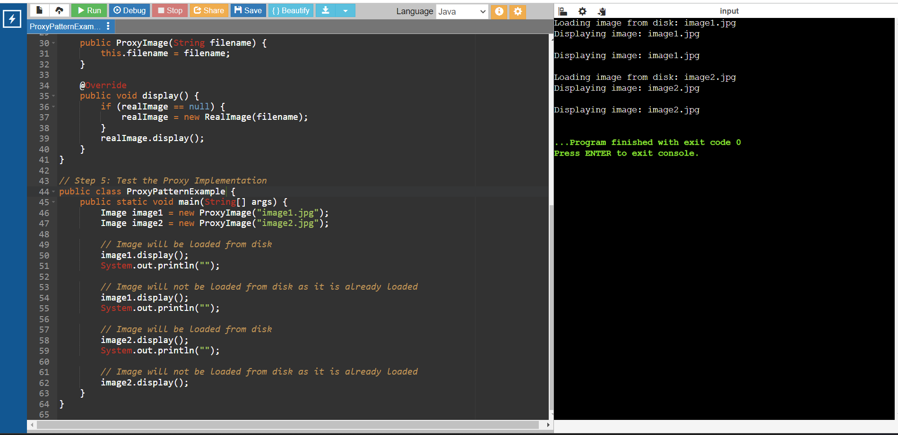

Exercise 7: Implementing the Observer Pattern

Scenario: You are developing a stock market monitoring application where multiple clients need to be notified whenever stock prices change. Use the Observer Pattern to achieve this.
import java.util.ArrayList;
import java.util.List;
interface Stock {
void registerObserver(Observer o);
void deregisterObserver(Observer o);
void notifyObservers();
}
class StockMarket implements Stock {
private List<Observer> observers;
private double stockPrice;

public StockMarket() {
this.observers = new ArrayList<>();
}
public void registerObserver(Observer o) {
observers.add(o);
}
public void deregisterObserver(Observer o) {
observers.remove(o);
}
public void notifyObservers() {
for (Observer o : observers) {
o.update(stockPrice);
}
}
public void setStockPrice(double stockPrice) {
this.stockPrice = stockPrice;
notifyObservers();
}}
interface Observer {
void update(double stockPrice); }
class MobileApp implements Observer {
private String appName;
public MobileApp(String appName) {
this.appName = appName;
}
public void update(double stockPrice) {
System.out.println(appName + " received stock price update: " + stockPrice);
}}
class WebApp implements Observer {
private String appName;
WebApp(String appName) {
this.appName = appName;
}
public void update(double stockPrice) {
System.out.println(appName + " received stock price update: " + stockPrice);
}}
public class ObserverPatternExample {
public static void main(String[] args) {
StockMarket stockMarket = new StockMarket();

Observer mobileApp = new MobileApp("MobileApp");
Observer webApp = new WebApp("WebApp");

stockMarket.registerObserver(mobileApp);
stockMarket.registerObserver(webApp);

stockMarket.setStockPrice(100.00);
stockMarket.setStockPrice(101.50);

stockMarket.deregisterObserver(webApp);
stockMarket.setStockPrice(102.75);
}
}
Output:
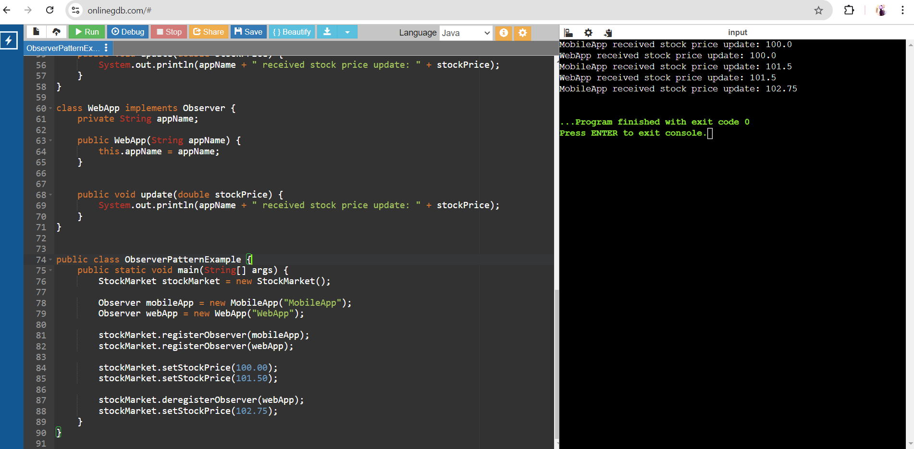

Exercise 8: Implementing the Strategy Pattern

Scenario: You are developing a payment system where different payment methods (e.g., Credit Card, PayPal) can be selected at runtime. Use the Strategy Pattern to achieve this.

// Define Strategy Interface
interface PaymentStrategy {
void pay(double amount);
}
class CreditCardPayment implements PaymentStrategy {
private String name;
private String cardNumber;
private String cvv;
private String expiryDate;
public CreditCardPayment(String name, String cardNumber, String cvv, String expiryDate) {
this.name = name;
this.cardNumber = cardNumber;
this.cvv = cvv;
this.expiryDate = expiryDate;
}
public void pay(double amount) {
System.out.println("Paid " + amount + " using Credit Card.");
}}
class PayPalPayment implements PaymentStrategy {
private String email;
private String password;
public PayPalPayment(String email, String password) {
this.email = email;
this.password = password;
}
public void pay(double amount) {
System.out.println("Paid " + amount + " using PayPal.");
}
}
class PaymentContext {
private PaymentStrategy paymentStrategy;
public void setPaymentStrategy(PaymentStrategy paymentStrategy) {
this.paymentStrategy = paymentStrategy;
}
public void executePayment(double amount) {
paymentStrategy.pay(amount);
}
}
public class StrategyPatternExample {
public static void main(String[] args) {
PaymentContext context = new PaymentContext();
context.setPaymentStrategy(new CreditCardPayment("John Doe", "1234567890123456", "123", "12/23"));
context.executePayment(100.0);
context.setPaymentStrategy(new PayPalPayment("john.doe@example.com", "password123"));
context.executePayment(200.0);
}}
Output:
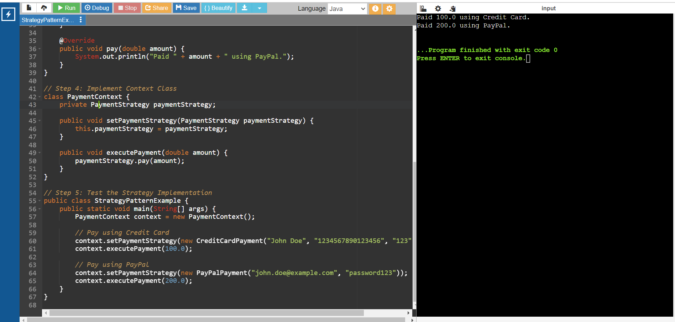

Exercise 9: Implementing the Command Pattern

Scenario: You are developing a home automation system where commands can be issued to turn devices on or off. Use the Command Pattern to achieve this.
//Define Command interface
interface Command {
void execute();
}
class LightOnCommand implements Command {
private Light light;
public LightOnCommand(Light light) {
this.light = light;
}
@Override
public void execute() {
light.turnOn();
}
}
class LightOffCommand implements Command {
private Light light;
public LightOffCommand(Light light) {
this.light = light;
}
@Override
public void execute() {
light.turnOff();
}
}
class Light {
public void turnOn() {
System.out.println("The light is on");
}
public void turnOff() {
System.out.println("The light is off"); } }
class RemoteControl {
private Command command;
public void setCommand(Command command) {
this.command = command;
}
public void pressButton() {
command.execute();
}
}
public class CommandPatternExample {
public static void main(String[] args) {
Light livingRoomLight = new Light();
Command lightOn = new LightOnCommand(livingRoomLight);
Command lightOff = new LightOffCommand(livingRoomLight);
RemoteControl remote = new RemoteControl();
remote.setCommand(lightOn);
remote.pressButton();
remote.setCommand(lightOff);
remote.pressButton();
}}
Output: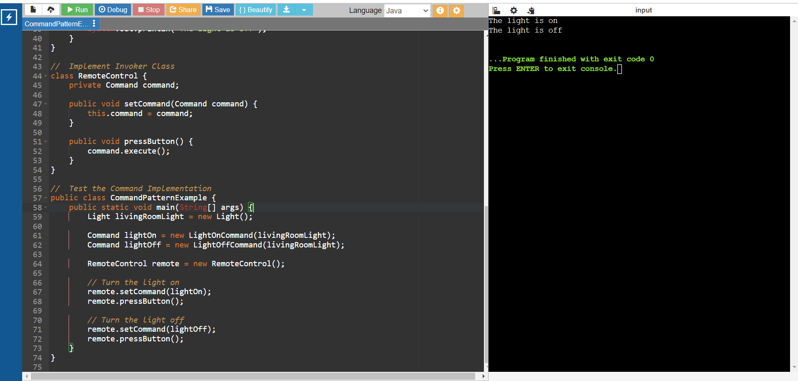

Exercise 10: Implementing the MVC Pattern

Scenario: You are developing a simple web application for managing student records using the MVC pattern.
// Define Model Class
class Student {
private String id;
private String name;
private String grade;
public Student(String id, String name, String grade) {
this.id = id;
this.name = name;
this.grade = grade;
}
public String getId() {
return id;
}
public void setId(String id) {
this.id = id;
}
public String getName() {
return name;
}
public void setName(String name) {
this.name = name;
}
public String getGrade() {
return grade;
}
public void setGrade(String grade) {
this.grade = grade;
}
}
class StudentView {
public void displayStudentDetails(String studentName, String studentId, String studentGrade) {
System.out.println("Student Details:");
System.out.println("Name: " + studentName);
System.out.println("ID: " + studentId);
System.out.println("Grade: " + studentGrade);
}
}
class StudentController {
private Student model;
private StudentView view;
public StudentController(Student model, StudentView view) {
this.model = model;
this.view = view;
}
public void setStudentName(String name) {
model.setName(name);
}
public String getStudentName() {
return model.getName();
}
public void setStudentId(String id) {
model.setId(id);
}
public String getStudentId() {
return model.getId();
}
public void setStudentGrade(String grade) {
model.setGrade(grade);
}
public String getStudentGrade() {
return model.getGrade();
}
public void updateView() {
view.displayStudentDetails(model.getName(), model.getId(), model.getGrade());
}}
public class MVCPatternExample {
public static void main(String[] args) {
Student model = new Student("1", "John Doe", "A");
StudentView view = new StudentView();
StudentController controller = new StudentController(model, view);
controller.updateView();
controller.setStudentName("Jane ");
controller.setStudentGrade("B");
// Display updated student details
controller.updateView();
}}
Output:
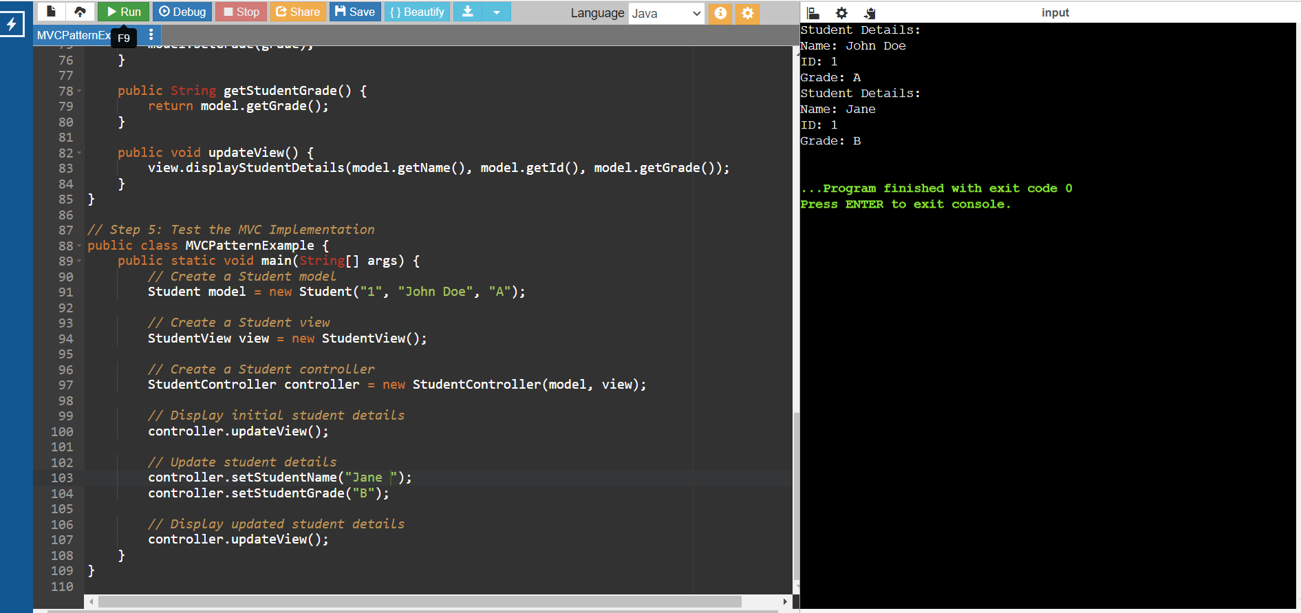

Exercise 11: Implementing Dependency Injection

Scenario: You are developing a customer management application where the service class depends on a repository class. Use Dependency Injection to manage these dependencies.
//Define CustomerRepository interface
interface CustomerRepository {
String findCustomerById(String id);
}
// Implement Concrete Repository
class CustomerRepositoryImpl implements CustomerRepository {
public String findCustomerById(String id) {
// Mock implementation, in real scenario, it would interact with a database
if (id.equals("1")) {
return "John Doe";
} else {
return "Customer not found";
}}}
// Define Service Class
class CustomerService {
private CustomerRepository customerRepository;
// Implement Dependency Injection
public CustomerService(CustomerRepository customerRepository) {
this.customerRepository = customerRepository;
}
public String getCustomerDetails(String id) {
return customerRepository.findCustomerById(id);
}}
// Test the Dependency Injection Implementation
public class DependencyInjectionExample {
public static void main(String[] args) {
// Create a CustomerRepository instance
CustomerRepository customerRepository = new CustomerRepositoryImpl();
// Inject the repository into the service
CustomerService customerService = new CustomerService(customerRepository);
// Use the service to find customer details
String customerDetails = customerService.getCustomerDetails("1");
System.out.println("Customer Details: " + customerDetails);
}
}
Output:
